Reinforcement Learning to play Super Mario Bros
Shen Rutian 20225027
Abstract
In this project, we explore algorithms that use reinforcement learning to play the Super Mario Bros.Proximal Policy Optimization, or PPO, is a policy gradient method for reinforcement learning. The motivation was to have an algorithm with the data efficiency and reliable performance of TRPO, while using only first-order optimization.The PPO method has Significant advantages in handling games.

1 Introduction
In recent years, artificial intelligence has made significant progress and is increasingly being used in daily life and work.Artificial intelligence has many classifications, among which reinforcement learning is an important part.Reinforcement learning not only utilizes existing data, but also obtains new data through exploration of the environment, and utilizes new data to repeatedly update and iterate machine learning algorithms for existing models. Learning is to better explore the environment, and exploration is to obtain data for better learning.
So Reinforcement learning has significant advantages in AI Go and AI games.We can study the performance of reinforcement learning in some games to deepen our understanding of reinforcement learning
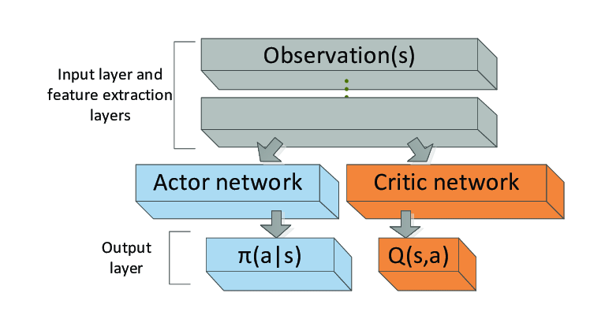
2 Related Work
Reinforcement learning: Reinforcement learning summarizes models from data, and the processed data only contains the model's scoring values, without knowing what the model specifically outputs. Therefore, algorithms can only be relied on to continuously explore and find the optimal model. The most significant example is the Go game, which lacks guidance on each move and can only be scored based on the final win or loss, independently exploring and finding the best model.
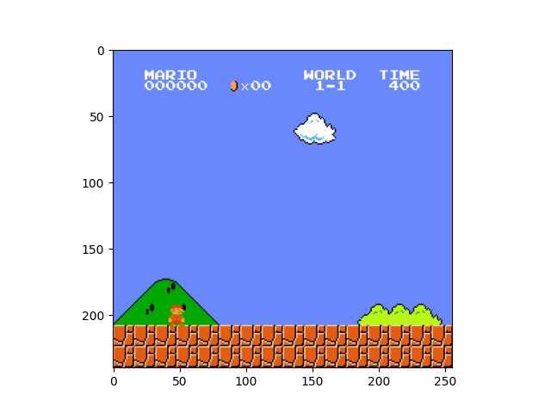

Convolutional Neural Networks:When we process the frame of the game,we need use the convolutional neural network to make the computer understand the vision.Convolution neural network is a kind of feedforward neural network with convolution computation and deep structure, which is one of the representative algorithms of deep learning. Convolutional neural networks have the ability to represent learning and can perform translation invariant classification of input information according to their hierarchical structure, hence they are also known as "translation invariant artificial neural networks".

PPO:We propose a new series of strategy gradient methods for reinforcement learning, which alternate between data sampling and optimizing the "proxy" objective function using random gradient ascent through interaction with the environment. The standard strategy gradient method performs a gradient update on each data sample, and we propose a new objective function that can perform small batch updates for multiple epochs. The new method we call Approximate Policy Optimization (PPO) has some advantages of Trust Region Policy Optimization (TRPO), but their implementation is much simpler, more versatile, and has better sample complexity (empirically). Our experiment tested PPO on a series of benchmark tasks, including simulating robot motion and Atari games. We showed that PPO outperformed other online strategy gradient methods, and overall achieved a favorable balance between sample complexity, simplicity, and barrier time

3 Task definition
We plan to play Super Mario, a very classic retro game. Formally, an agent interacts with an environment E in a sequence of actions, observations and rewards.In this game, the environment is Mario's running environment, and the reward is the running time and the number of coins and monsters killed in the game.
Our task is to learn an algorithm that allows Mario to survive longer and complete tasks.

4 Approach
In this project,We used Gym's Super Mario environment, which provides a ready-made operating environment and action options. We can use some simple code to make Mario run.These environments allow 3 attempts (lives) to make it through the 32 stages in the game. The environments only send reward-able game-play frames to agents; No cut-scenes, loading screens, etc. are sent from the NES emulator to an agent nor can an agent perform actions during these instances. If a cut-scene is not able to be skipped by hacking the NES's RAM, the environment will lock the Python process until the emulator is ready for the next action.

4.1 PPO
The Proximal Policy Optimization algorithm combines ideas from A2C (having multiple workers) and TRPO (it uses a trust region to improve the actor).The main idea is that after an update, the new policy should be not too far from the old policy. For that, ppo uses clipping to avoid too large update.
The PPO propose a new family of policy gradient methods for reinforcement learning, which alternate between sampling data through interaction with the environment, and optimizing a "surrogate" objective function using stochastic gradient ascent. Whereas standard policy gradient methods perform one gradient update per data sample, we propose a novel objective function that enables multiple epochs of minibatch updates. The new methods, which we call proximal policy optimization (PPO), have some of the benefits of trust region policy optimization (TRPO), but they are much simpler to implement, more general, and have better sample complexity (empirically). Our experiments test PPO on a collection of benchmark tasks, including simulated robotic locomotion and Atari game playing, and we show that PPO outperforms other online policy gradient methods, and overall strikes a favorable balance between sample complexity, simplicity, and wall-time.

4.2 Grayscale:
Because neural networks need to calculate the number of images in each layer, ordinary color image calculations are too complex. We can first reduce the image to a grayscale image before performing calculations. The grayscale processing is provided in the GYM installation package, which is very convenient.

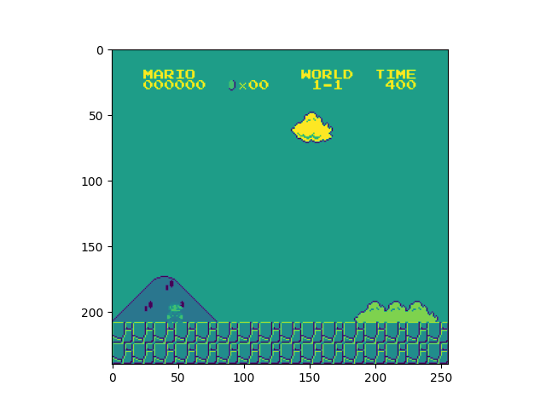

4.3 Stacking frames
Creates a simple vectorized wrapper for multiple environments, calling each environment in sequence on the current Python process. This is useful for computationally simple environment such as Cartpole-v1, as the overhead of multiprocess or multithread outweighs the environment computation time. This can also be used for RL methods that require a vectorized environment, but that you want a single environments to train with

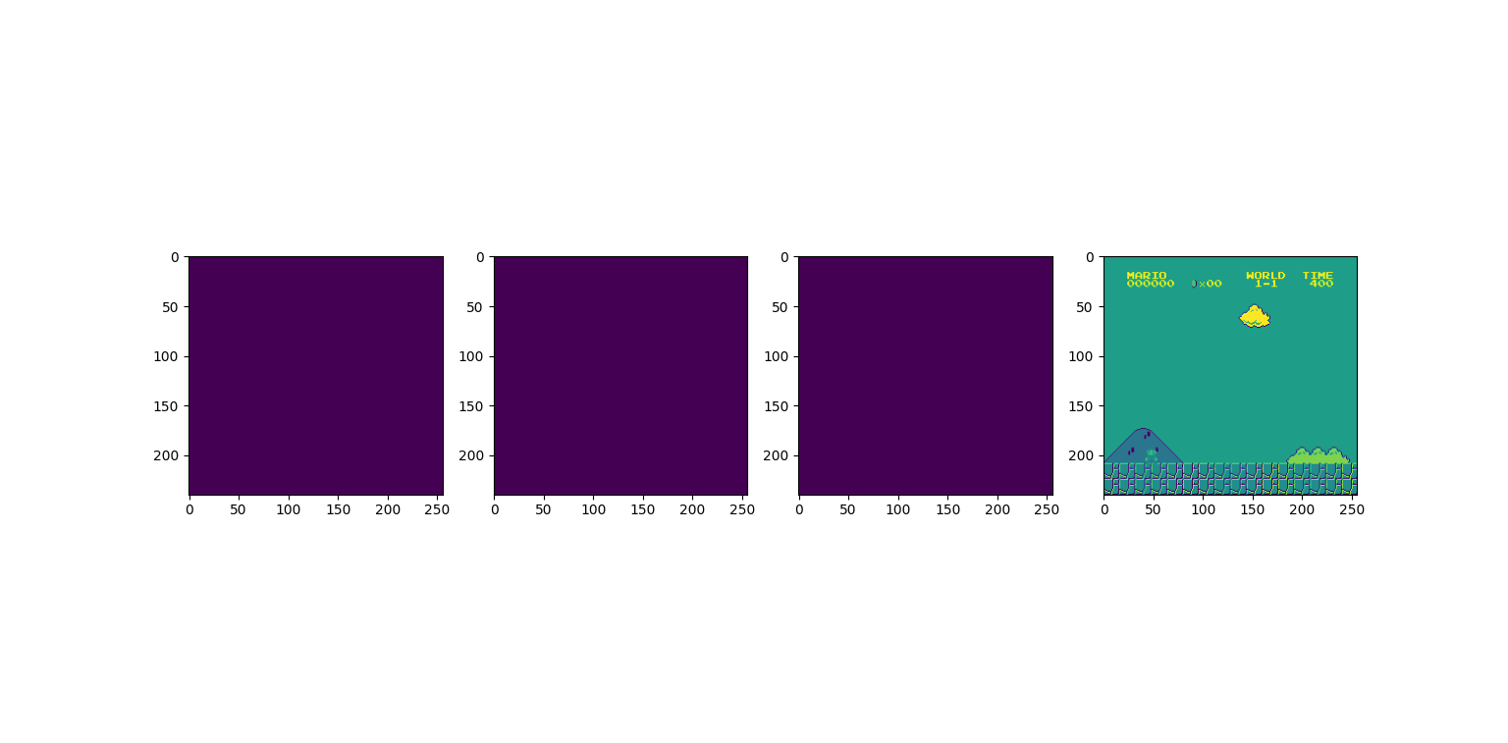

4.4 Save the best strategy
We need algorithms to evolve the best strategy over and over again, so we need to preserve the best strategy. This requires us to be able to call and save, and we can borrow the data package from Stable Laboratory to implement this process.In the process of finding the optimal model, we need to constantly adjust our hyperparameter. Find the optimal solution during the adjustment process and save it.

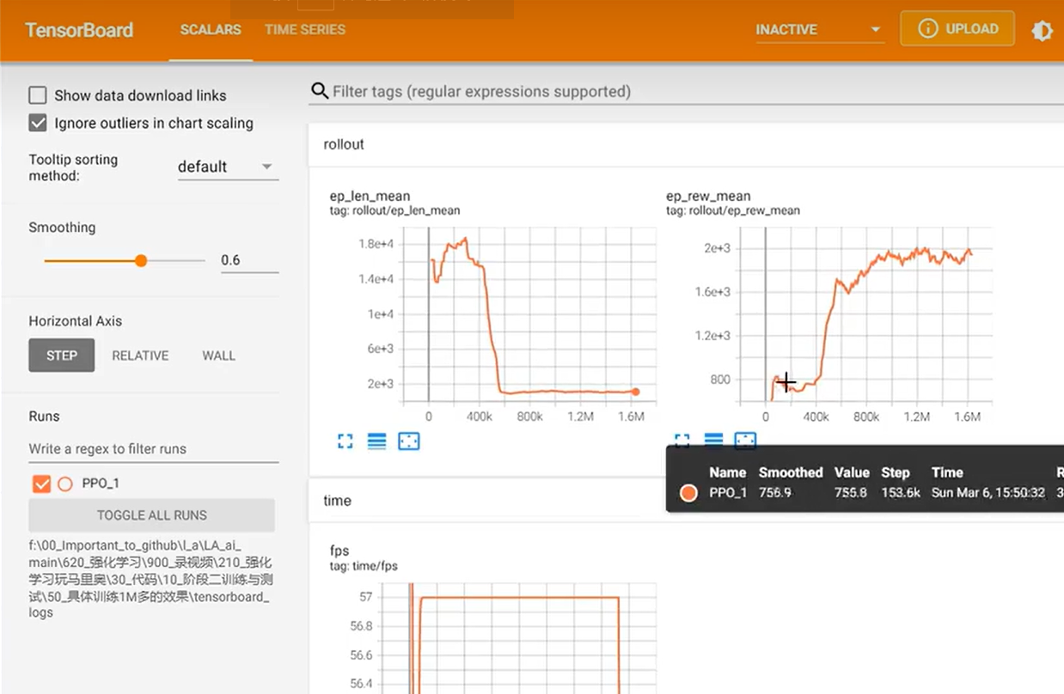

5 Data and Experiments
We conducted our experiments using the supermariobros environment in Gym Lab. The ppo algorithm we call in the process. The installation package of the stable laboratory that we call for the ppo algorithm.The PPO propose a new family of policy gradient methods for reinforcement learning, which alternate between sampling data through interaction with the environment, and optimizing a "surrogate" objective function using stochastic gradient ascent. PPO is a policy gradient method where policy is updated explicitly. We can write the objective function or loss function of vanilla policy gradient with advantage function. If the advantage function is positive, then it means action taken by the agent is good and we can a good reward by taking the action.
We finally conducted 450000 training sessions, which greatly improved Mario's operational strategy compared to the beginning. At the beginning of the training, Mario will be stuck in one place for a long period of ineffective training. After 450000 training sessions, Mario can cleverly avoid which trap. But in order for Mario to run better, more training is needed.

